FuP schedule checker user guide:
- Save standard schedule table (.xls file) in the local drive. The file should not have access restricted to a particular user.
- Export project schedule table from T3000 and save it the local drive.
- Use “main.exe” to open the application. Alternatively, “main.py” can be used if python is installed and all python dependencies (modules) are installed in the computer.
- Following window will open. Use “Select Program” menu to switch the program to “FuP schedule checker”.
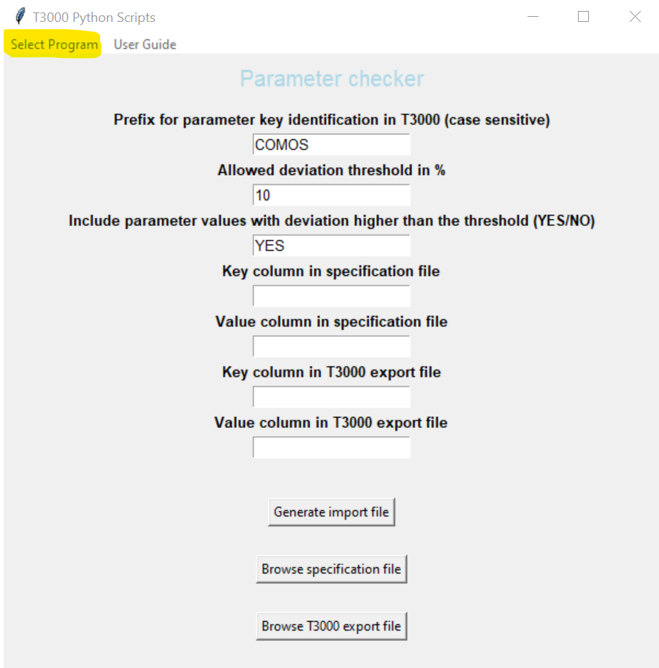

- Following window will appear upon switching the program. The entry fields will be populated after browsing the required files.
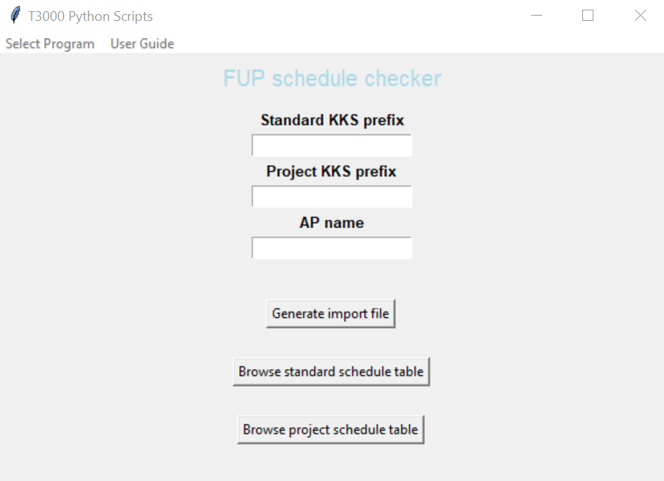
- Browse and select the standard schedule file. (“.xls” file saved during S/N-1 of this document)
- Browse and select the project schedule file. (“.xls” file saved during S/N-2 of this document)
- Check that the entry fields are correctly filled and modify if needed.
- Press the button “Generate import file”.
- If the program runs successfully, the folder “result” will open automatically. Two files will be generated. Analyze the results before import in T3000.
- “T3000_schedule_import.xls” – This file will be used to update T3000 FuP schedule.
- “T3000_schedule_check.xls” – This file will have two additional columns “Remarks” and “Standard Seq” and can be used to check that the result is as desired.
Note: In both of the generated files, the FUPs which are not present in standard schedule will be highlighted in yellow.

